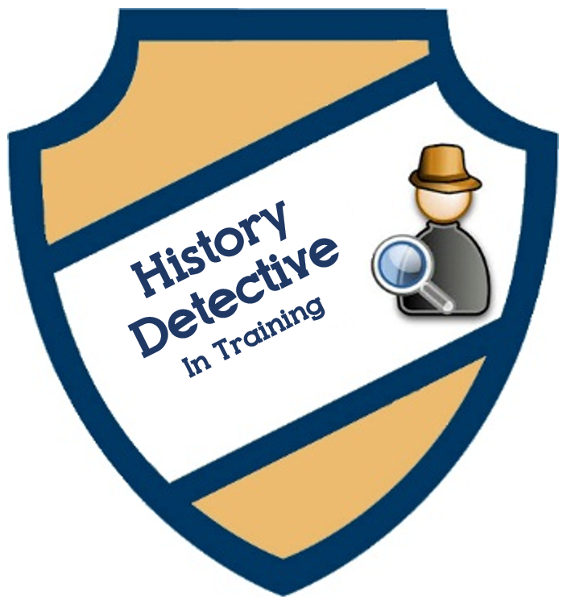

This notebook belongs to
Detective
Training Exercise: Curious Construction
Draw, in detail, one feature from the house or landscape that interests you.

Listen to the final clue in the mystery envelope before answering this last question.
What does looking at the research station from today tell us about life on Sable Island a hundred years ago? __________________________________________ __________________________________________________________________
Training Exercise: Object Investigations
List or draw at least ten things you notice about your object:

Listen to the final clue in the mystery envelope before answering this last question.
What can you infer about life in Sable Island by the observations you made about your chosen object? ______________
________________________________________________________________________
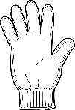
Training Exercise: Clues from the Archives
Brainstorm all the things you notice about your document. For each cloud you add, write or draw all the observations you have about that idea:

I think the most important clue is:

Listen to the final clue in the mystery envelope before answering this last question.
After making observations on your archival document, what is one new questions you have about life on Sable Island? ________________________________

Training Exercise: Modern Mysteries
Modern Item | Artifact (Old) | What similarities do the modern items and artifacts share? How are they different?
Light Source | 2. | Different: Lightbulb uses electricity.
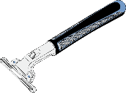  Razor |  | Different:
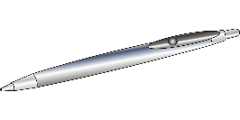  Pen |  | Different:
Lock |  | Different:
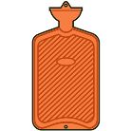  Hot Water  Heat Bag |  | Different:
Entertainment |  | Different:
Milk |  | Different:
Hand Soap |  | Different:
Google Map |  | Different:
Listen to the final clue in the mystery envelope before answering this last question.
Life today is the same as 100 years ago because: ______
Life today is different than 100 years ago because:

